**Report/Documentation for final project**

**Team**

**Yessenov Zhassulan 190103172 09-p made solo**

**Link to Database:**

[**https://www.kaggle.com/hernan4444/anime-recommendation-database-2020?select=anime.csv**](https://www.kaggle.com/hernan4444/anime-recommendation-database-2020?select=anime.csv)

**Some definition:** It’s an app which provide you with list of Japanese multiplication(it’s basically cartoons) which called anime.

Only two table was taken from link under: anime.csv(list of all multiplications with score, name, rating, duration , producers , genres and etc.) and rating.csv(rating score from users to definite anime)

They were too large so I decided to remove some elements for quickly execution

In anime table was about 15500 rows now its 1001 row, in rating table was approximately 57500000 rows now its about 8000000.

Also I created users table for users who will use my app.

**Task 2:**

Unfortunately I haven’t got one with the image

**Autofilled column**

I used the user table for trigger and one column from user table is autofills every time the user give a review score (review_num)

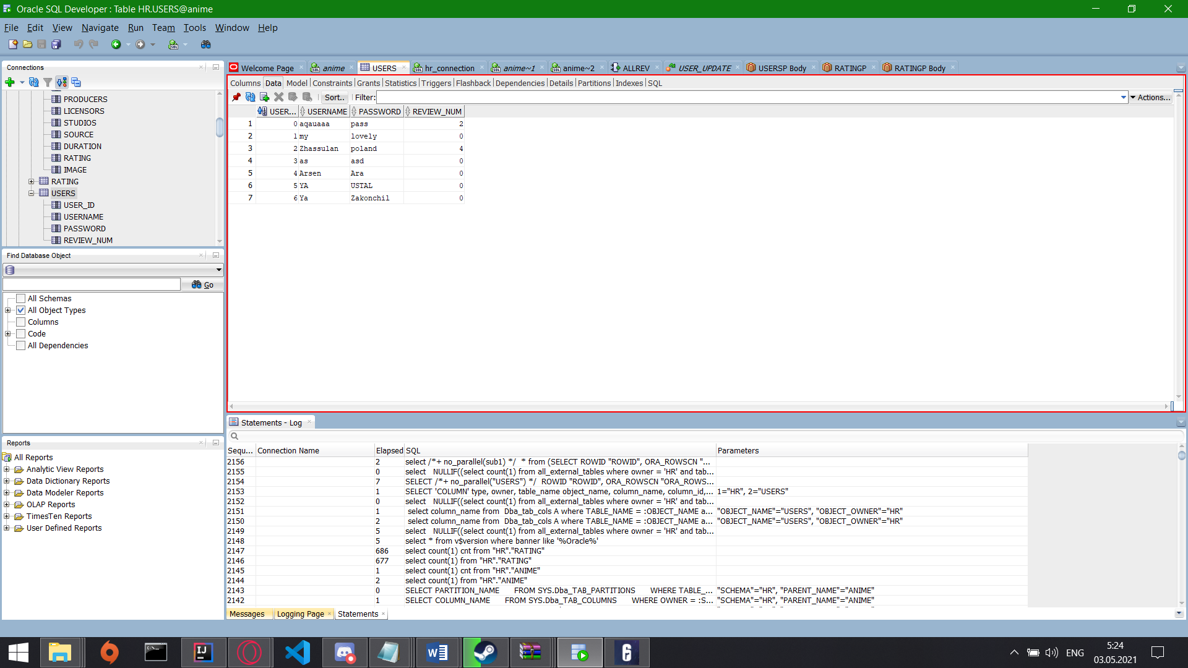

Here is a code:

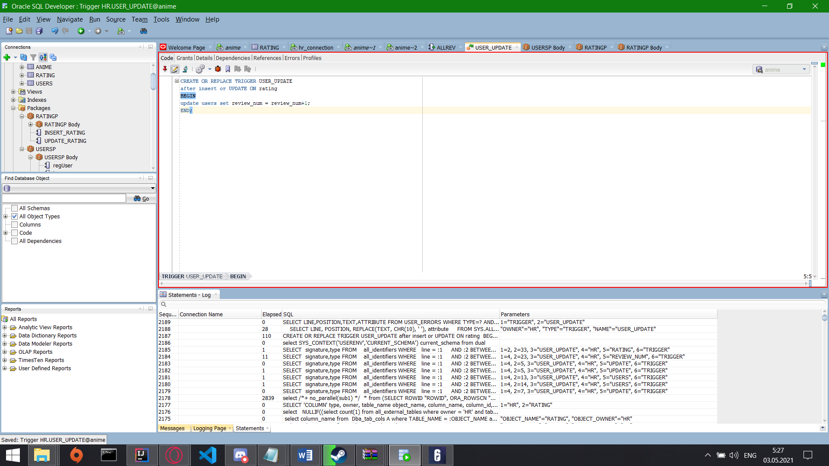

A little bit one

Second autoupdate column is on anime table which is update score of anime every time user give a new review or updates the existing one. It is on “ratingP” package

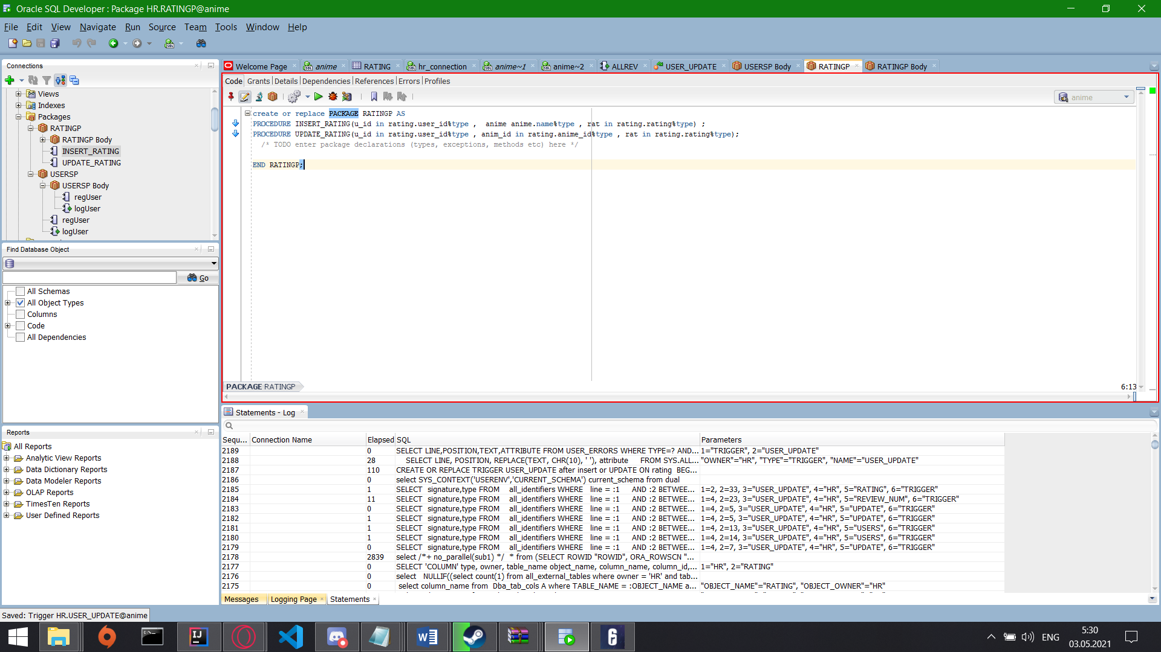

Package body:

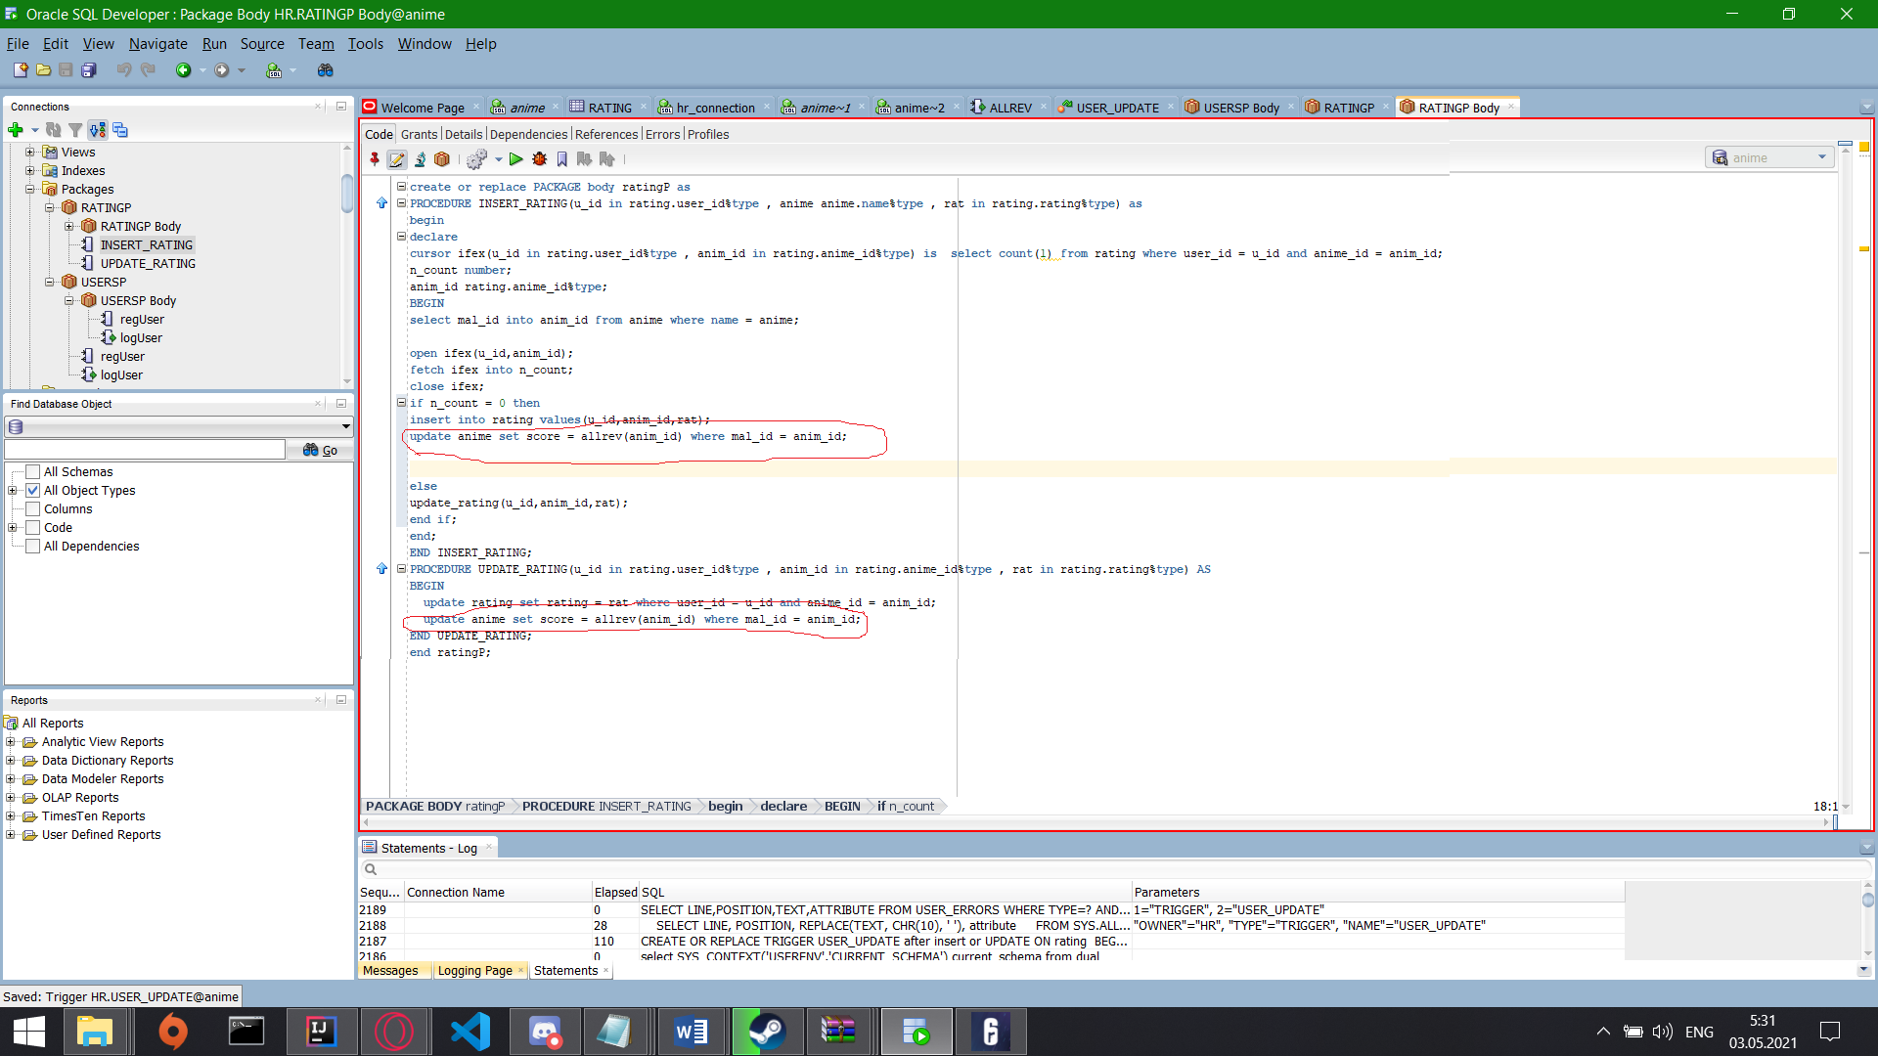

As u see I used not trigger but a function that return a new score of the cartoon Here it is:

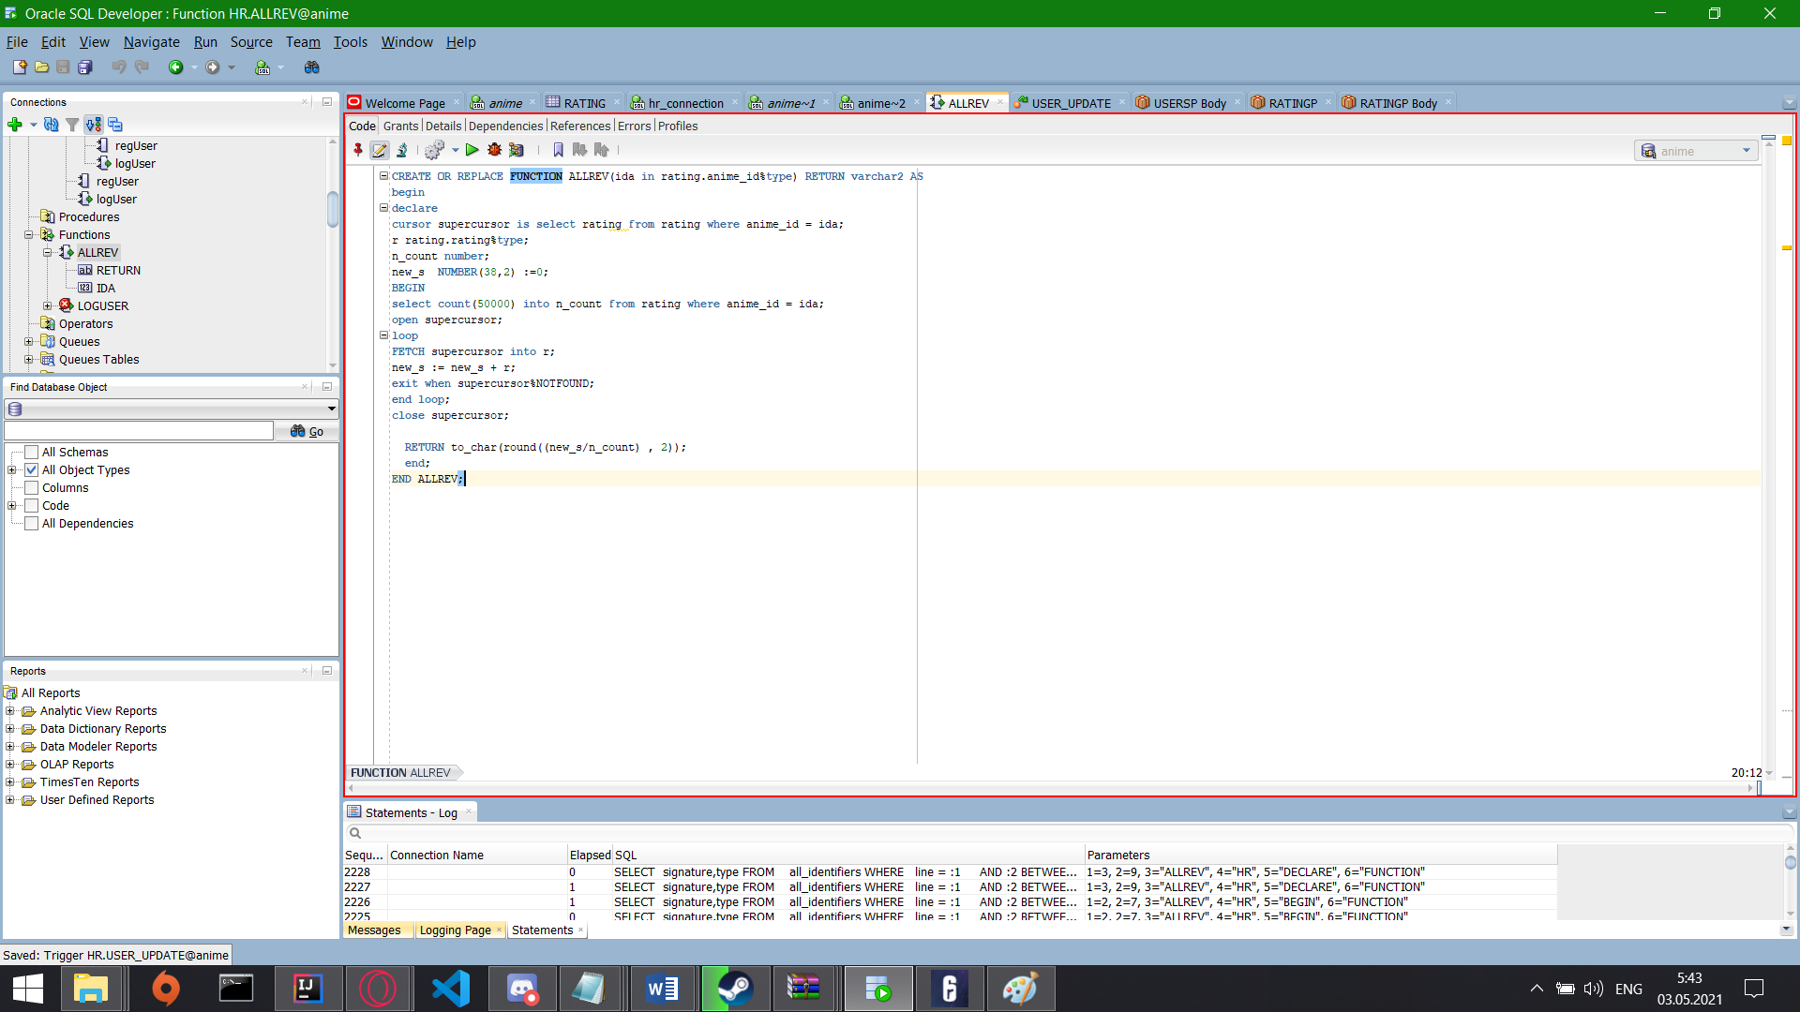

**About p/k and f/k:**here it is, users has a p/k as a user_id

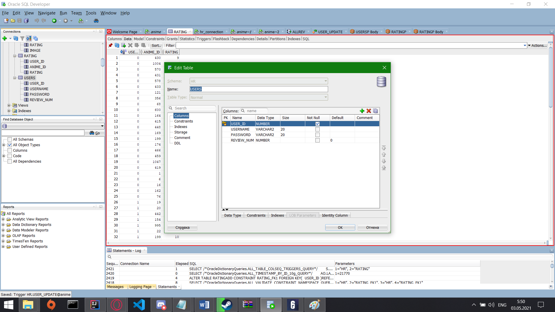

Anime has as mal_id

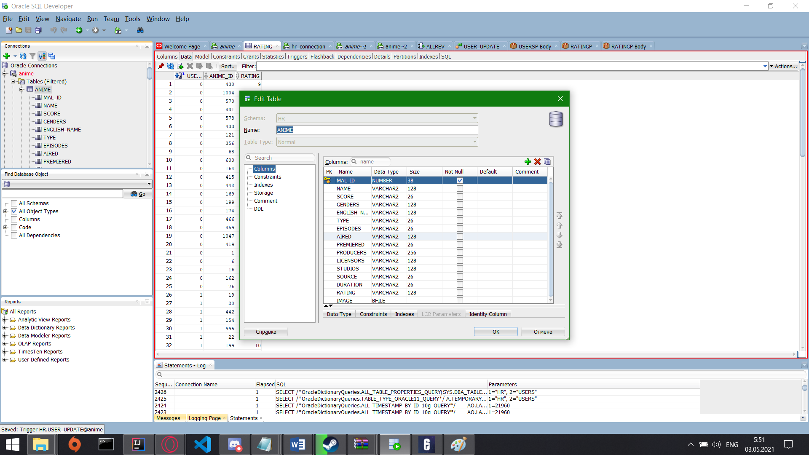

and a rating has a foreign key as rating.anime_id = anime.mal_id

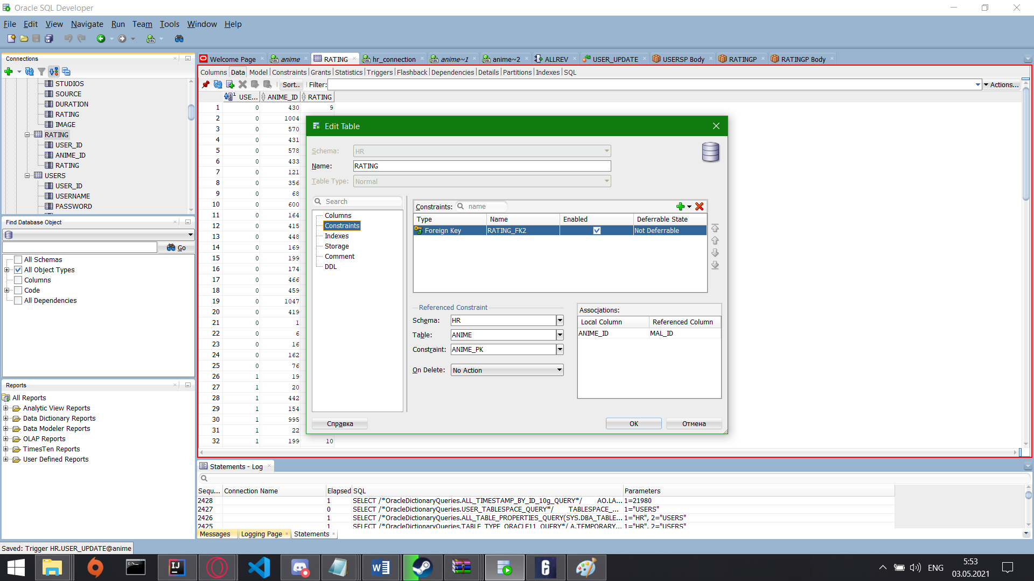

Ill load to github txt file with all codes in it.

**Task 3:**

My application has a **search**

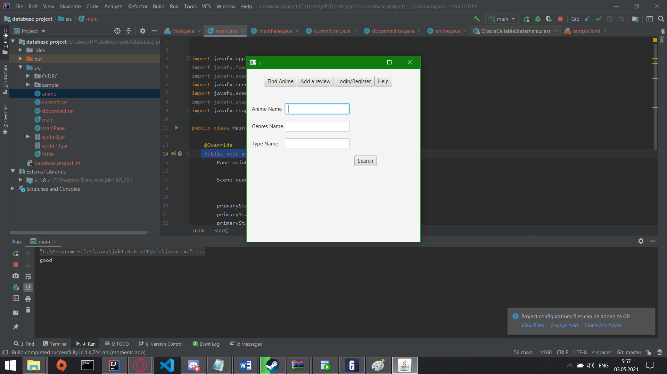

With sorting in it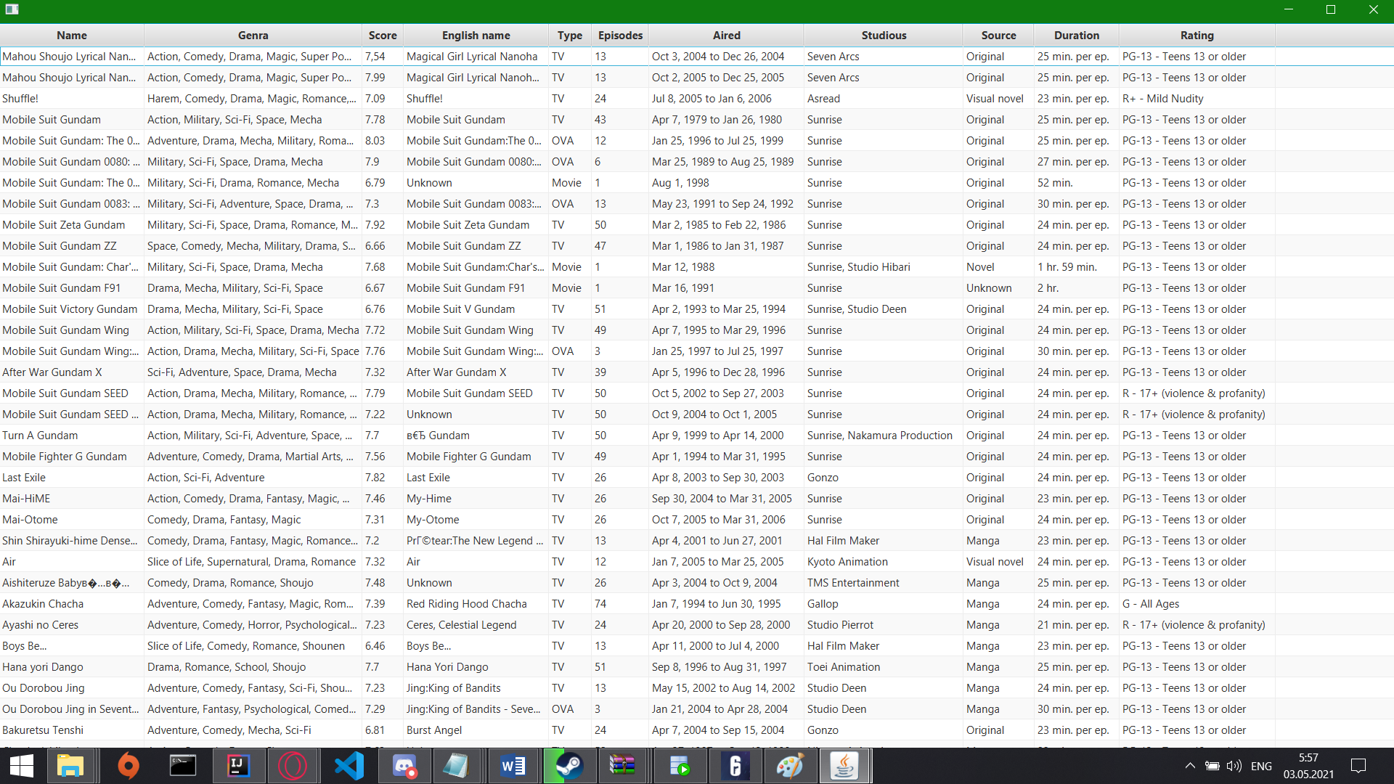

Has a **insert/update:**

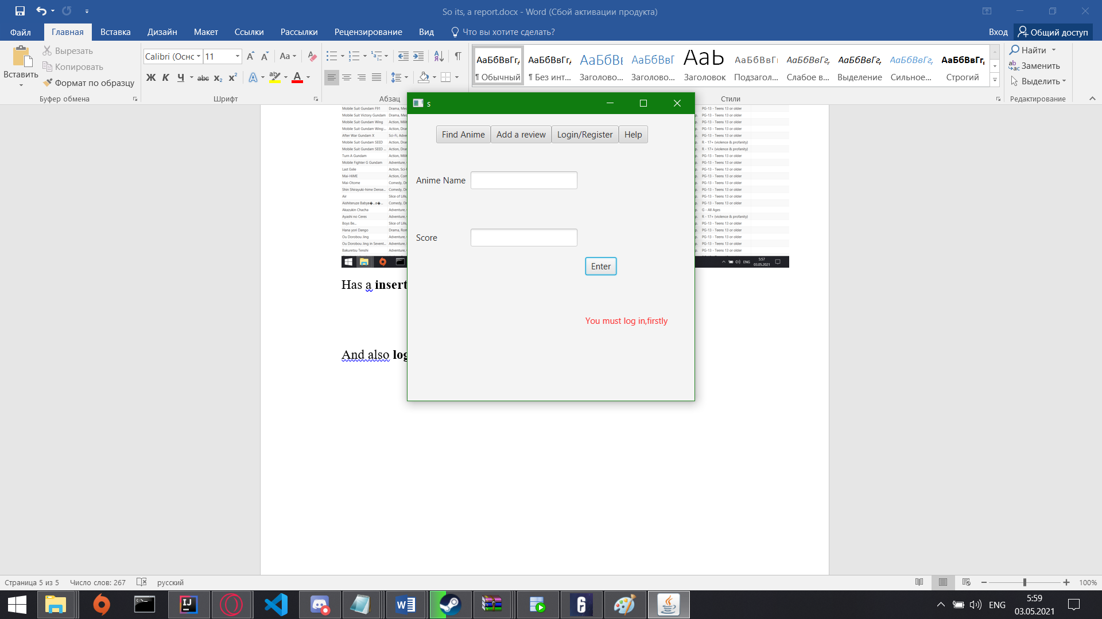

And also **login/register form:**

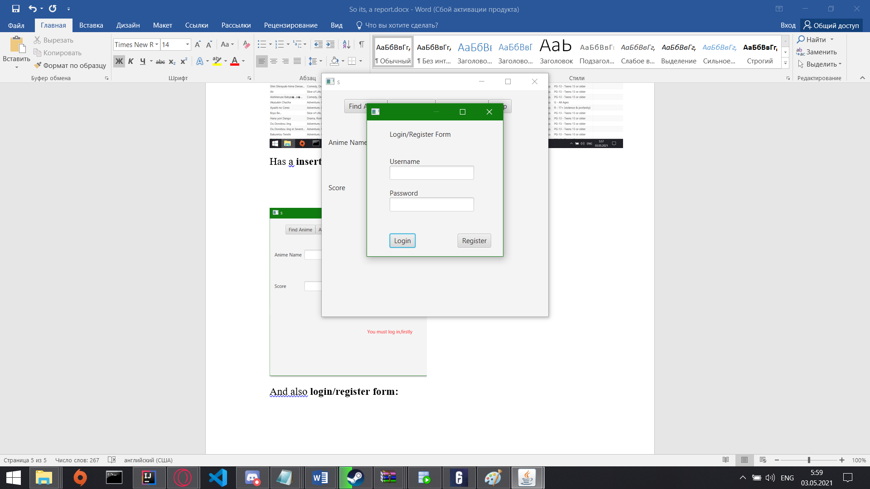

All code will be in github repo

As conclusion

My database has a

More or equal than 4 **function and procedure**

1 collection as a **type** **record**

1 **trigger**

**2 packages**

More or equal than **4 cursors**

**NONE of dynamic sql**

and one ***sequence***

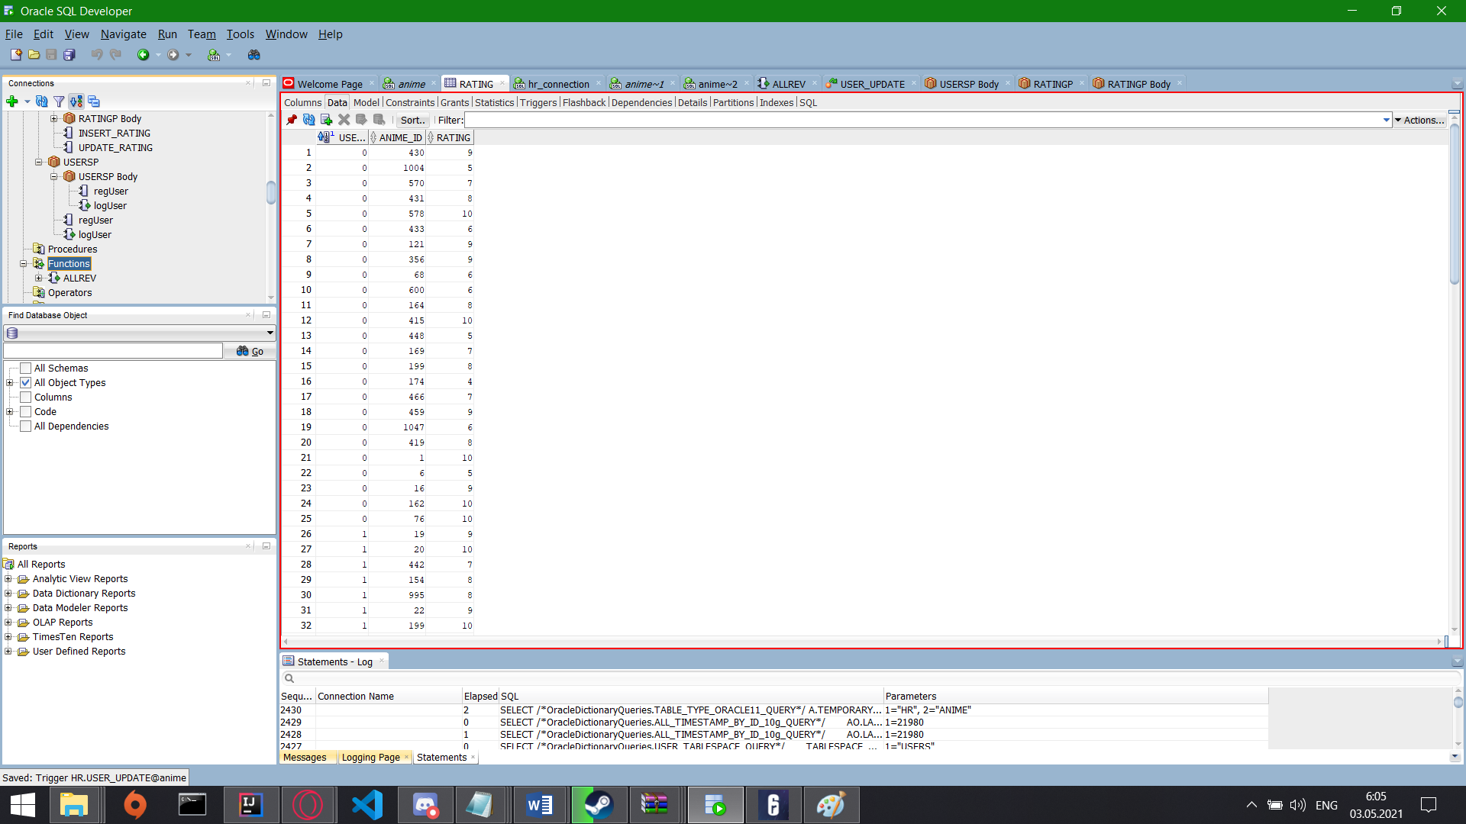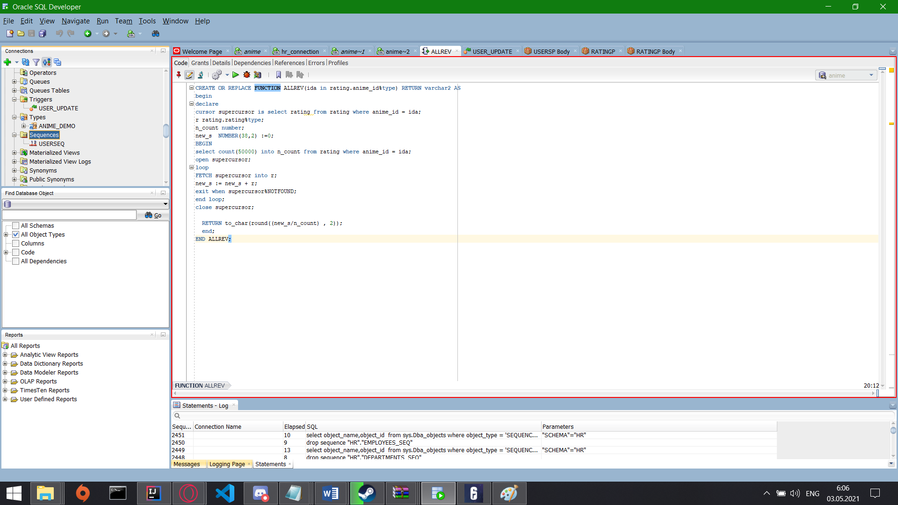

regUser procedure insert a new user to a usertable

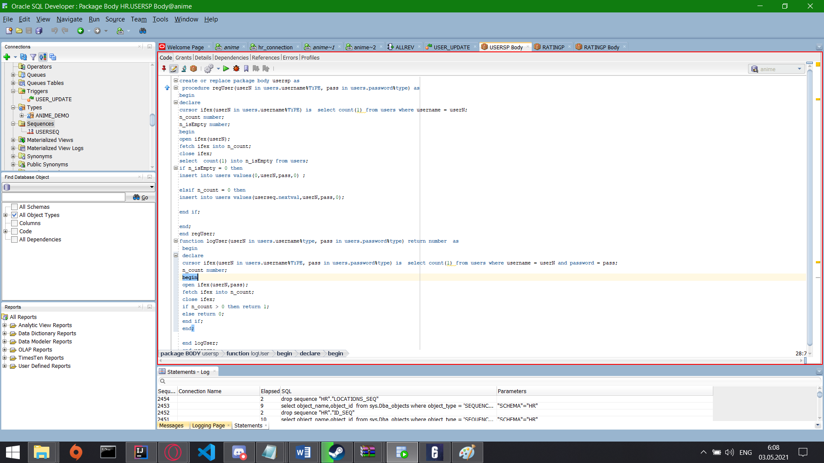

logIn function checks if the user exists and return 1 if true and 0 if false

